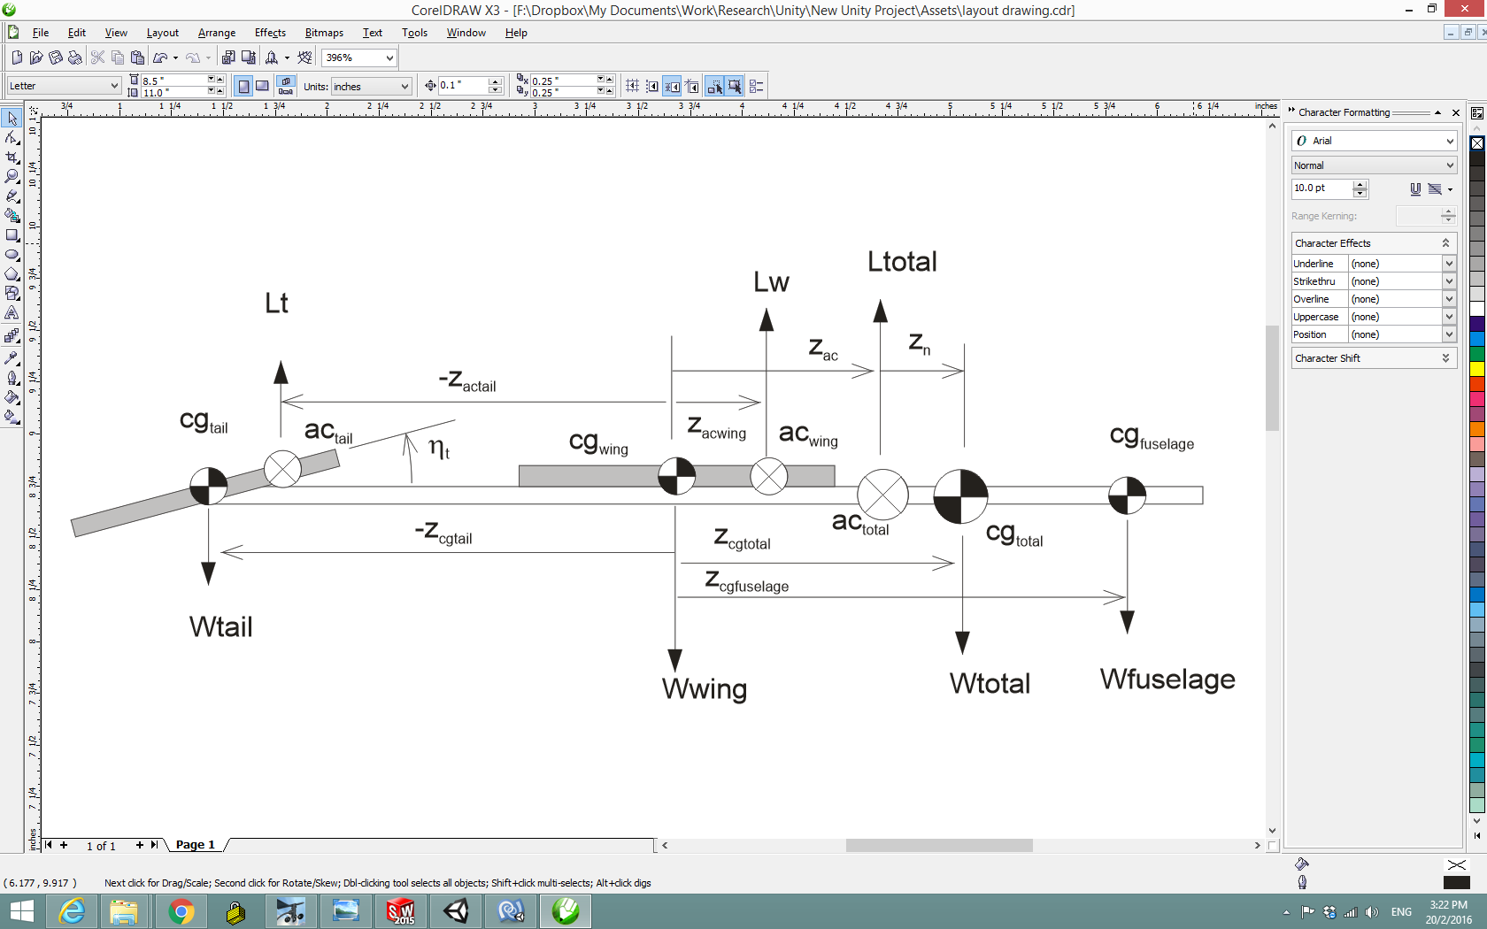

**Figure 1** *Definition of reference locations for longitudinal aerodynamic and mass balance*

First find the overall aircraft aerodynamic centre. Sum of anticlockwise moments due to lift about wing centre equals zero:

$$L_{w}{ Z}_{acwing}-\left(-z_{actail} L_{t}\right)-L_{total} Z_{ac}=0$$

$$z_{ac}=\frac{L_{w }{ z}_{acwing}+z_{actail} L_{t}}{L_{w}+L_{t}}$$

$$z_{ac}=\frac{a_{w}{S_{w} z}_{acwing}+{ a_{t}S_{t} z}_{actail} }{a_{w}S_{w}+a_{t}S_{t}}$$

Find the cg of the fuselage to achieve a given overall target cg position. Sum of gravitational moments about wing centre equals 0:

$$W_{f} z_{f}+ W_{t} z_{t}-W_{total} z_{cg}=0$$

$$z_{f}=\frac{W_{total} z_{cg}-W_{t} z_{t}}{W_{f}}$$

Find the tail setting angle to balance the aircraft at a given angle of attack. Sum of aerodynamic moments about the cg is zero.

$$a_{t}\left(α-η_{t}\right)qS_{t}\left(-z_{actail}+z_{cg}\right)=a_{w}αqS_{w}\left(z_{cg}-{ z}_{acwing}\right)$$

$$η=α\left(1+\frac{a_{w}S_{w}\left(z_{cg}-{ z}_{acwing}\right)}{a_{t}S_{t}\left(-z_{actail}+z_{cg}\right)}\right)$$